Morne du Toit

GYGVF2448

**Lecturer: Micheal Duve**

**March/April 2021**

ITECA3  
Deliverable 3

# User Manual

**Student name:** Morne du Toit

**Student Number:** GYGVF2448

**Project Title:** Hout E-Commerce

**Submission Date:** 25 June 2021

# Table of contents

Documentation & Coding **1**

Table of contents **2**

**2.1 Introduction** **3**

**2.2 Prototyping** **3**

2.3 Designing **16**

2.4 Coding **21**

2.5 Conclusion **27**

**2.6 Sign-off** **29**

# 1. Introduction

The client runs a small furniture business, called Hout, in which he locally manufactures his furniture, in the past, he would sell his products at local markets which would result in the client receiving a small profit margin. However, he would like to expand his business by first selling domestically and then globally, ensuring that the client maximizes their profits.

He plans to hire more staff to help him, but first, he would need to advertise to a new extension of customers, which currently seems impossible. Nevertheless, the client has decided to expand his business with an e-commerce site.

# 2. User Side

## Home Page

The user is greeted with a home page. The home page displays all the products for sale as well as a top navigation and a side navigation that allows the user to select a specific product category. Underneath each product is a quick button to add to a cart.

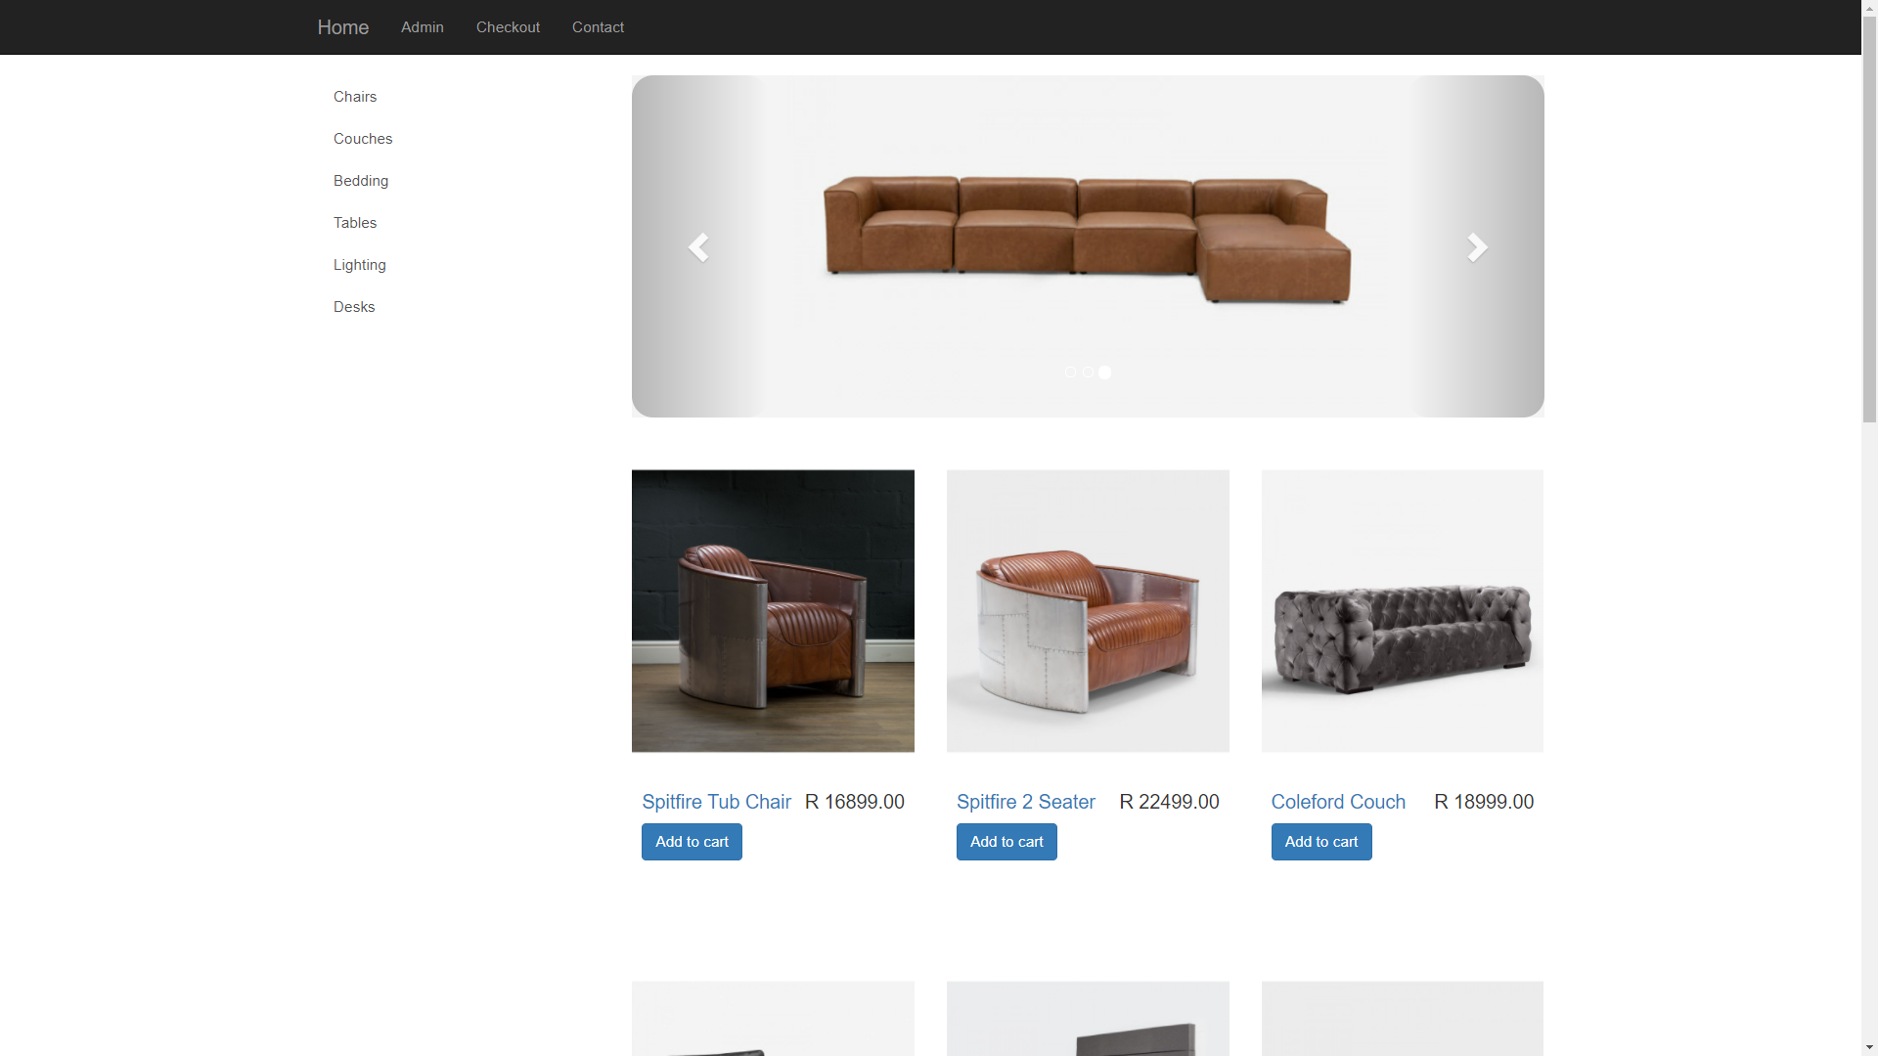

## Category Page

If the user selects a category in this case couches only the couches available will display.

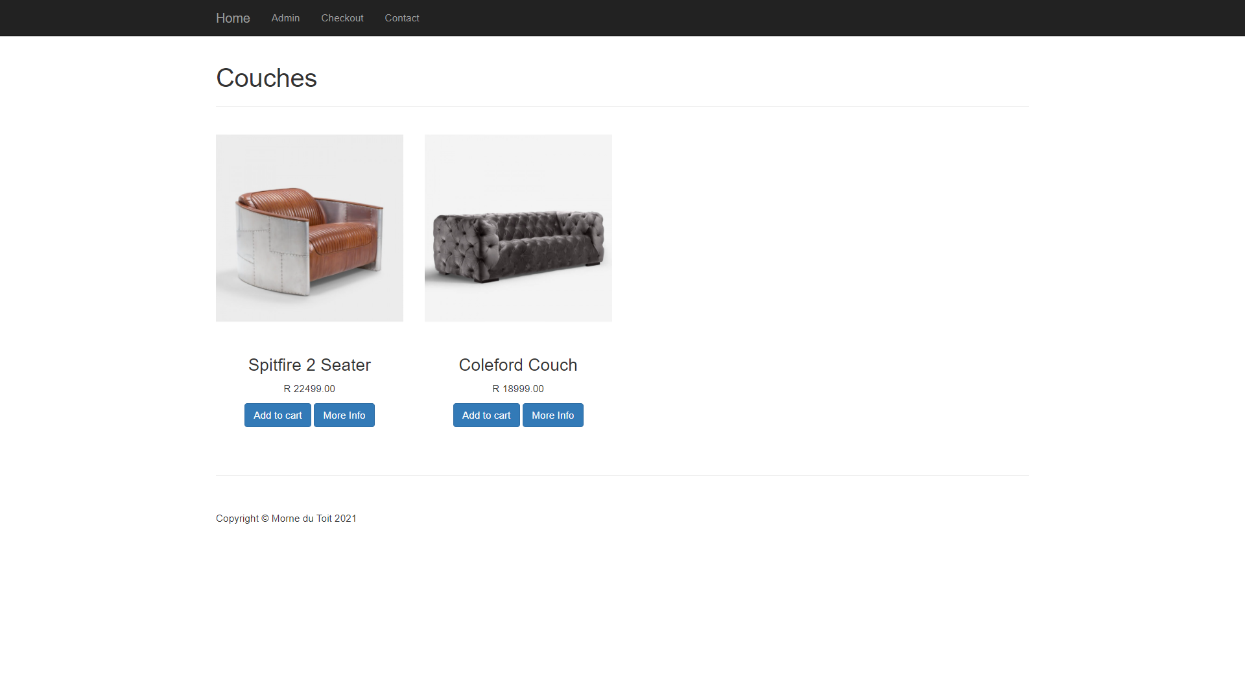

## Info Page

The user can now select the More Info button to read more information about the product.

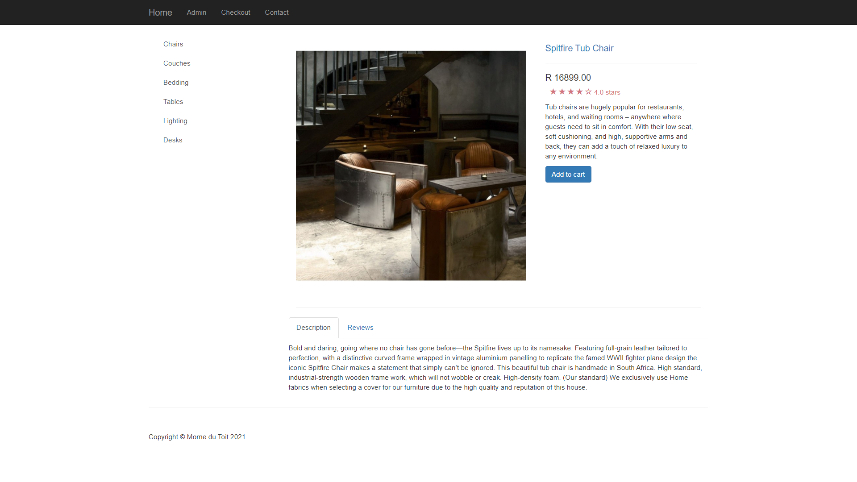

## Checkout Page

After being satisfied with the product and the user decide to buy the product the user can simply select the add to cart button which will add the product to the checkout page. On the checkout page, there is a buy button below the product added to the cart. On the right side of each item in the cart there appear 3 options (- + x) the - will decrement the amount and the + will increment the number of items the user would like to buy while the ‘x’ will simply remove the item completely from the cart. If the user is happy and everything is correct they can click the buy now button

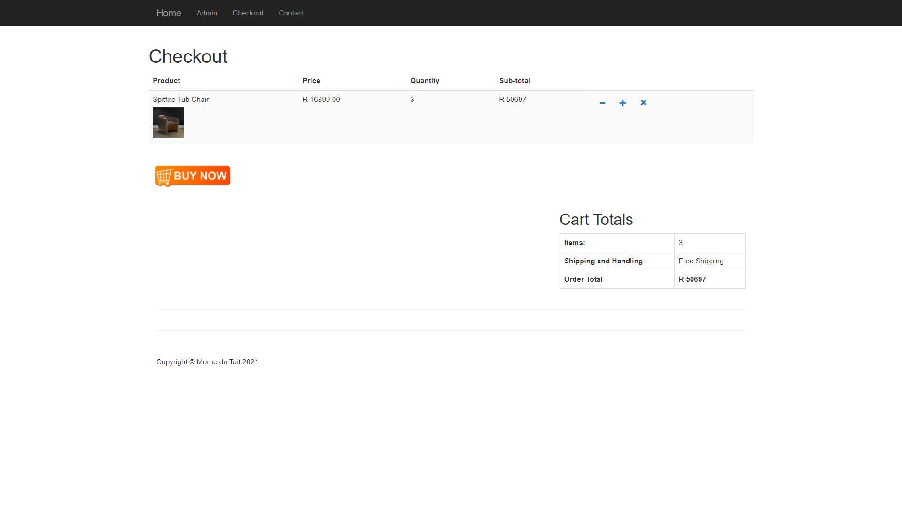

## Purchase confirmation

After clicking the buy now button the user will be redirected to the purchase confirmation page after clicking Pay now the user will pay for the products

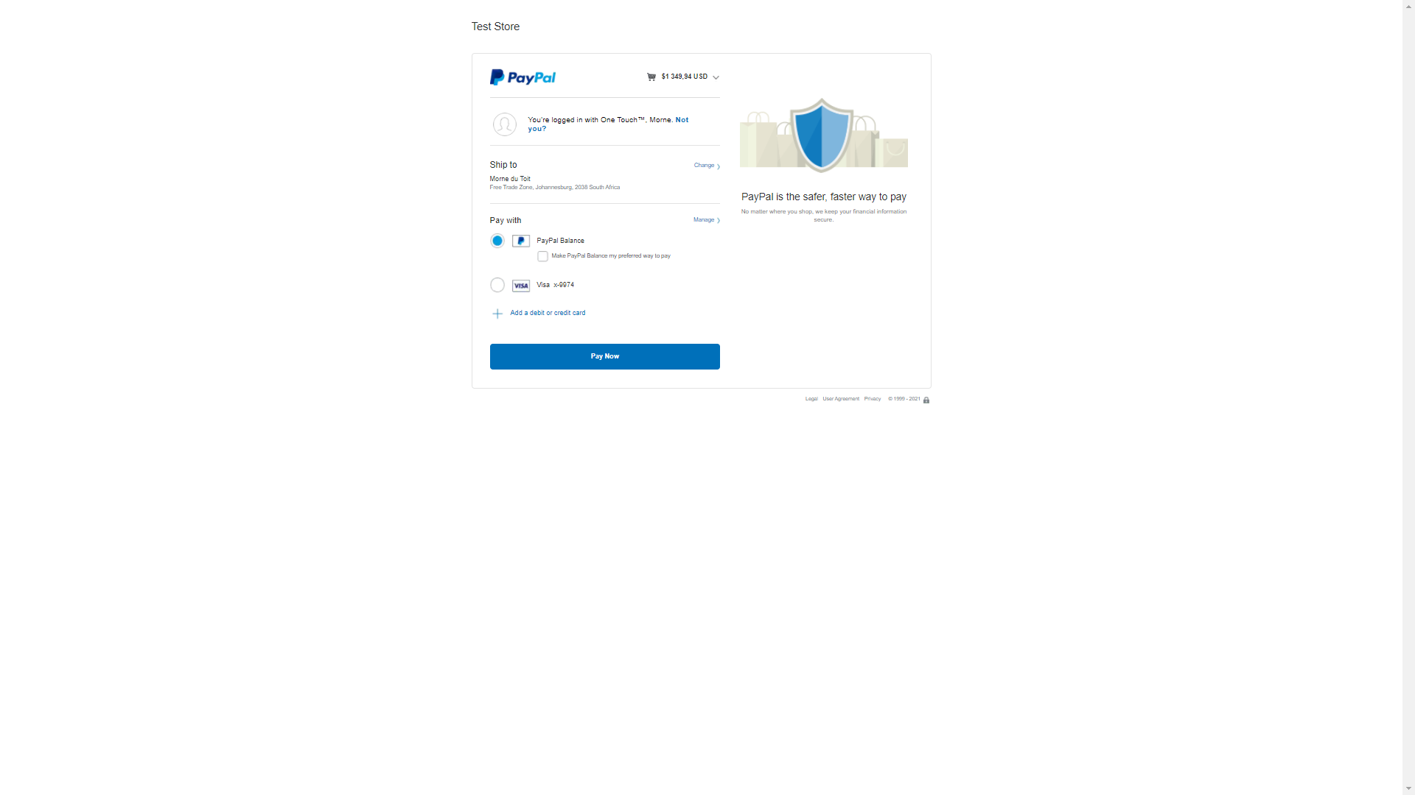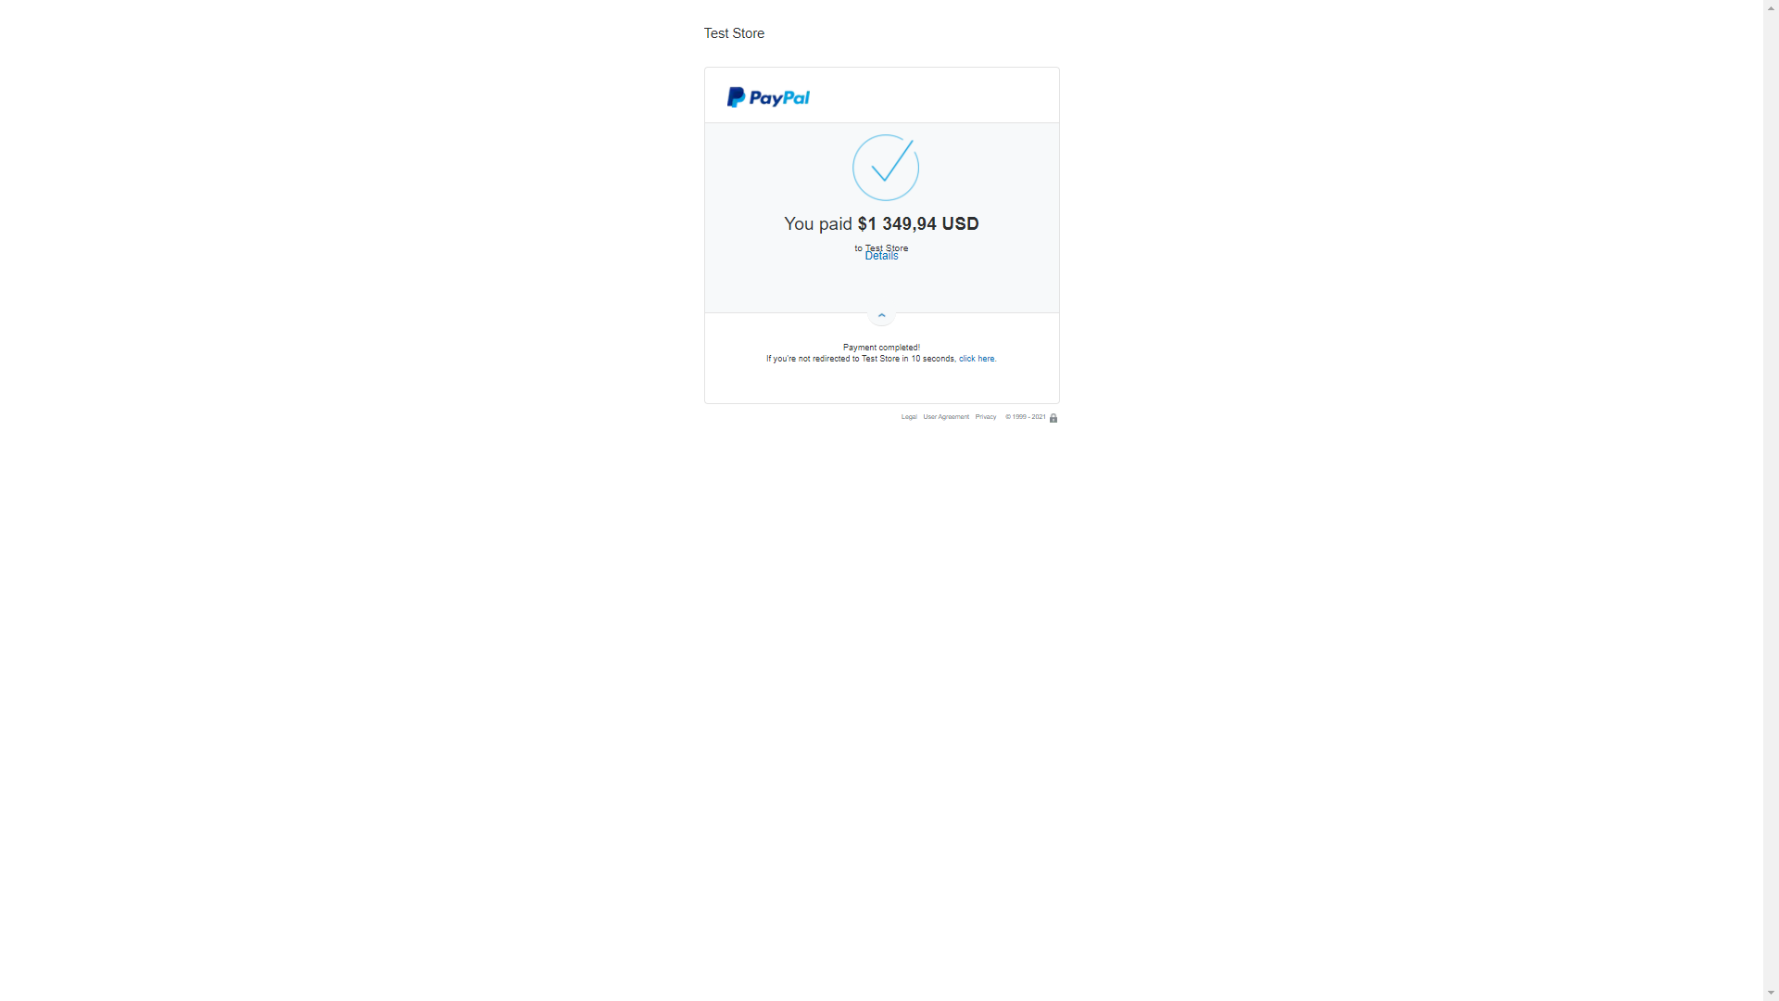

## Thank you Page

After the payment has been successfully completed the user will be redirected to the Thank you page.

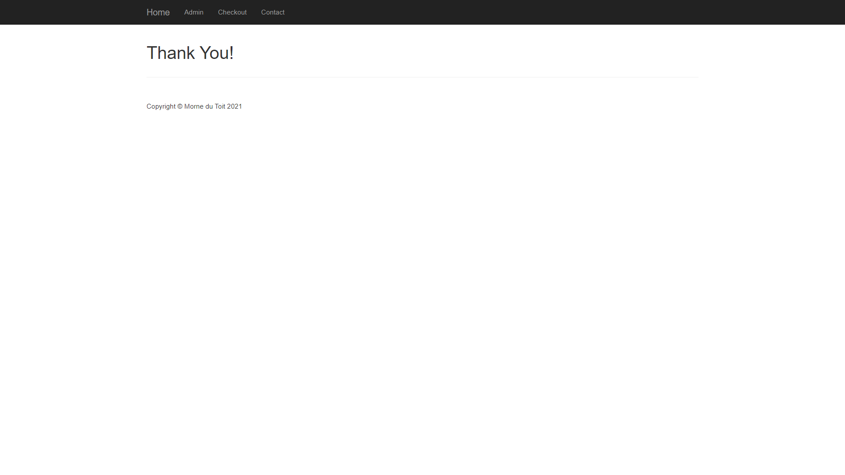

# 3. Admin Side

## Login Page

Once clicking on the admin label in the top navigation the admin user will be redirected to a login page where they will be required to enter valid credentials.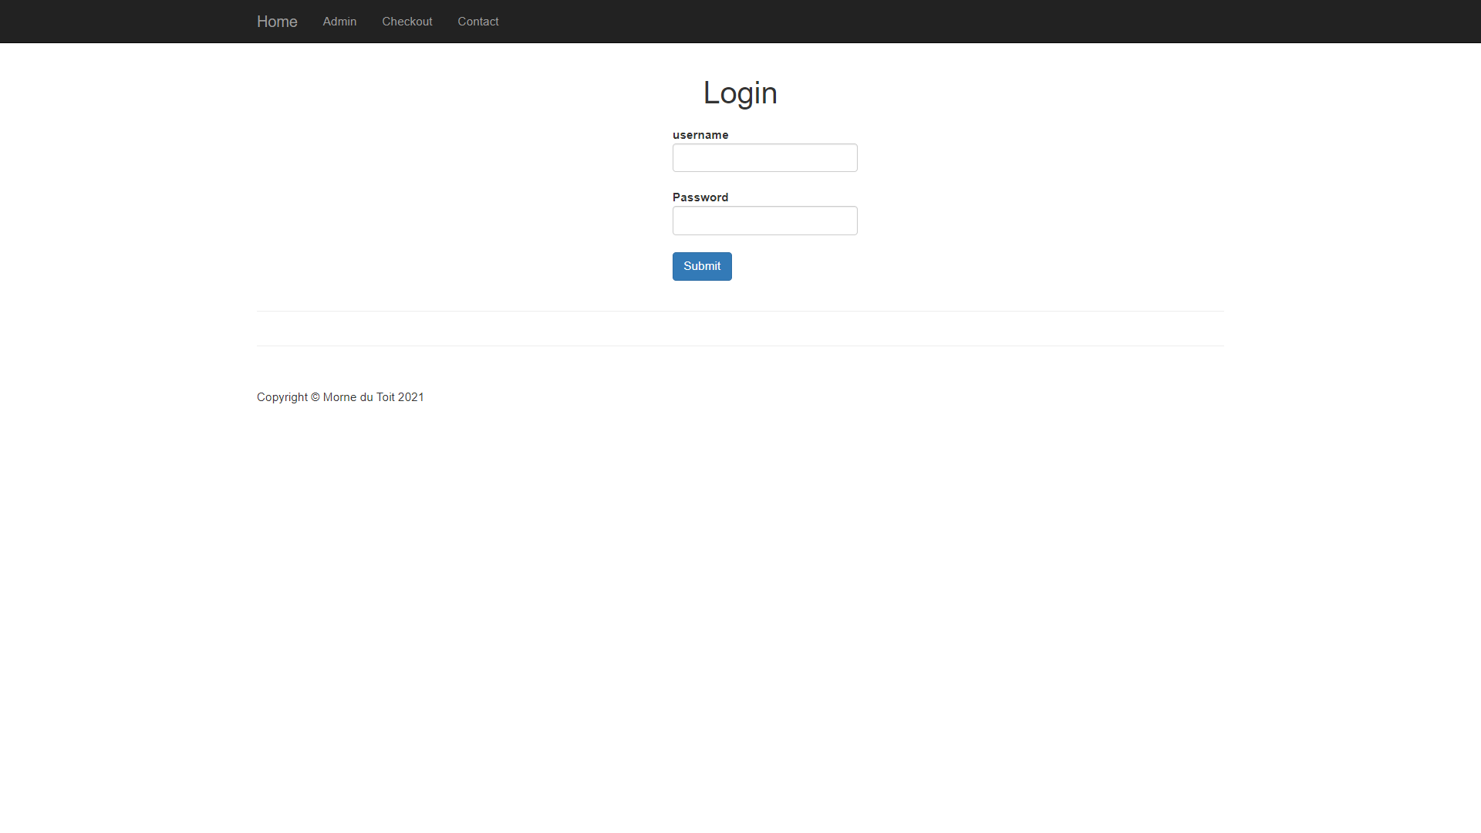

## All Orders

After logging in the admin user will be redirected to an all orders page where the admin user can see all the orders placed. The admin user will be given the option to delete any order by simply clicking the ‘x’. There is also a side navigation to help the admin user to navigate between different info screens.

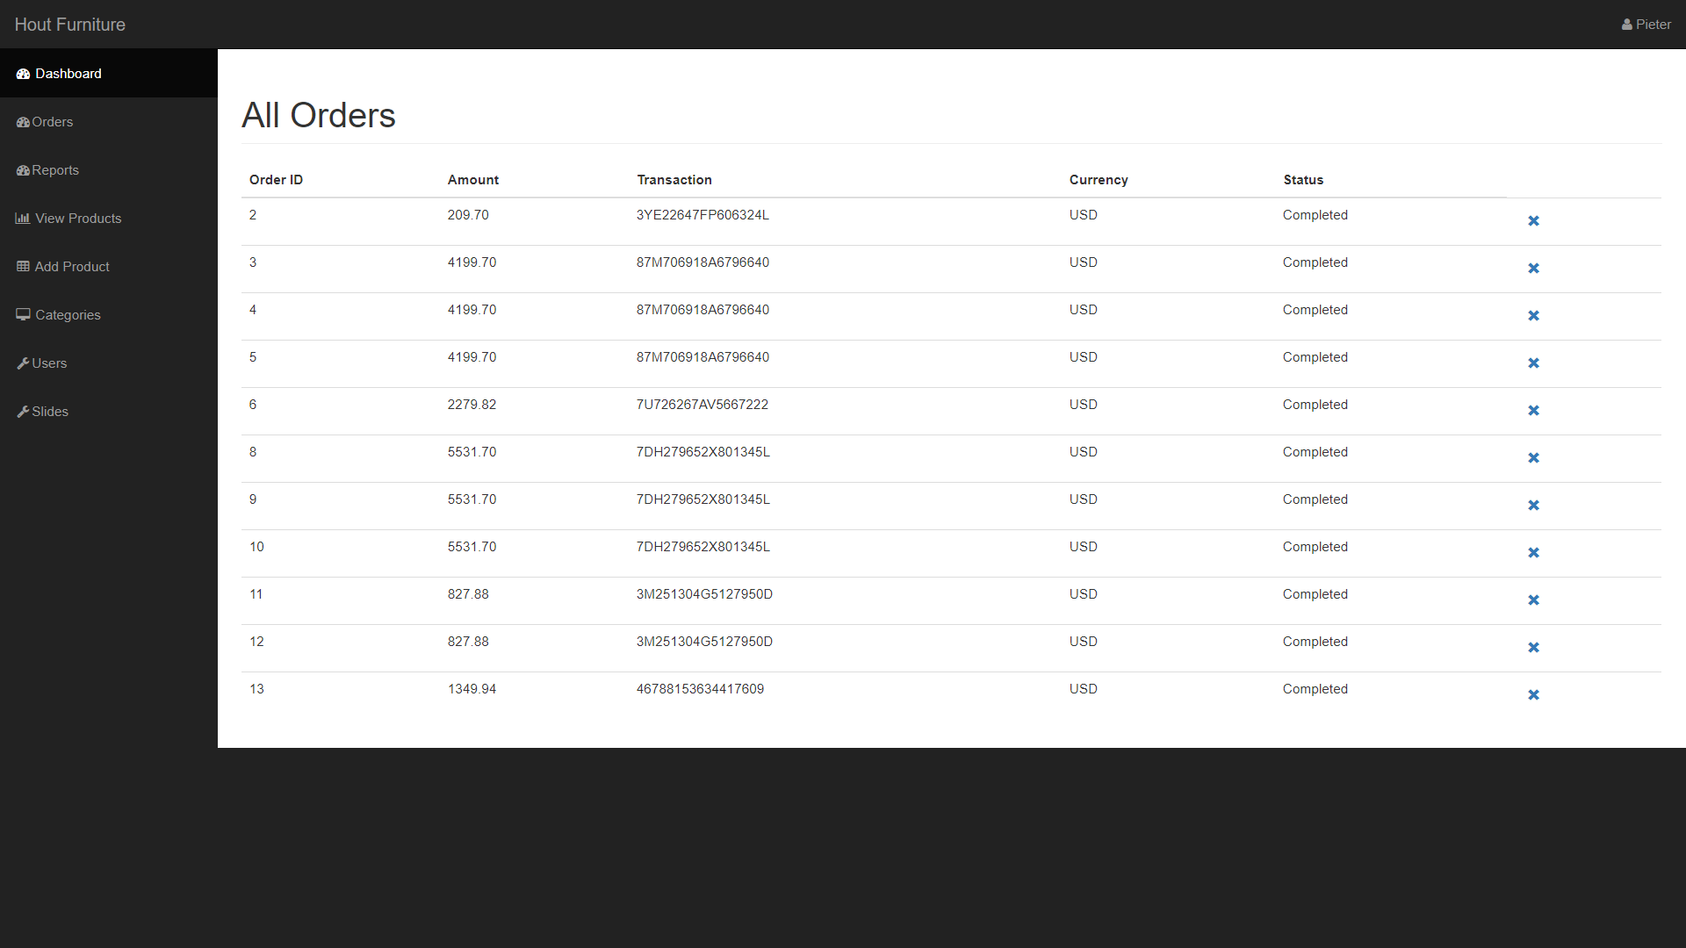

## Reports

After selecting the the reports label in the side navigation the admin user will be presented with the reports page. Just like the all orders page the admin user will have the ability to delete any report.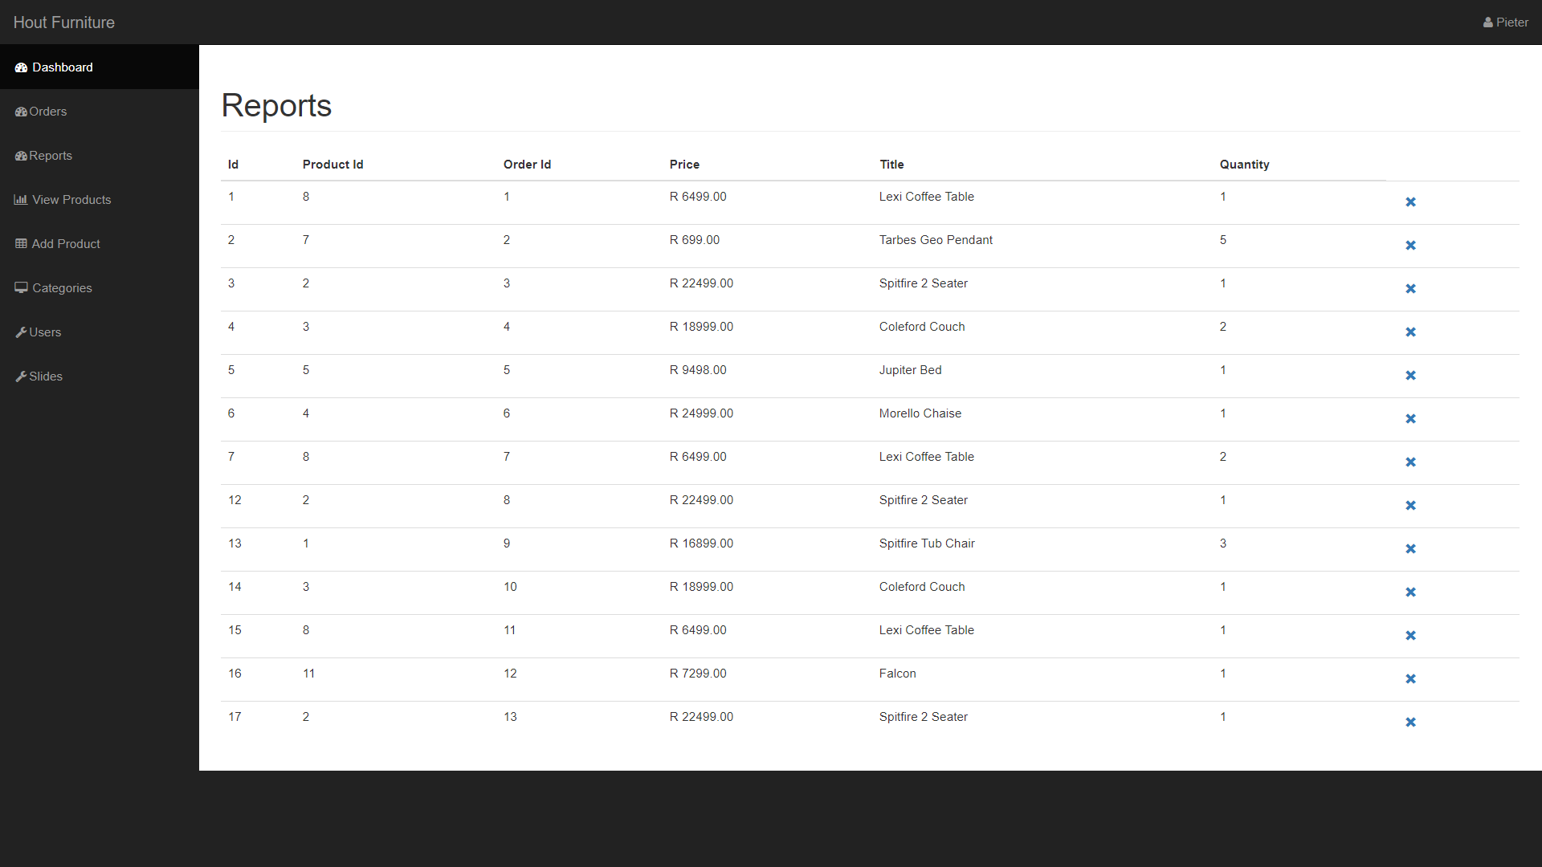

## View Products

After selecting the view products label in the side navigation the admin user will be able to see all of the products currently available for sale. The admin user will also be giving the option to edit or delete the products.

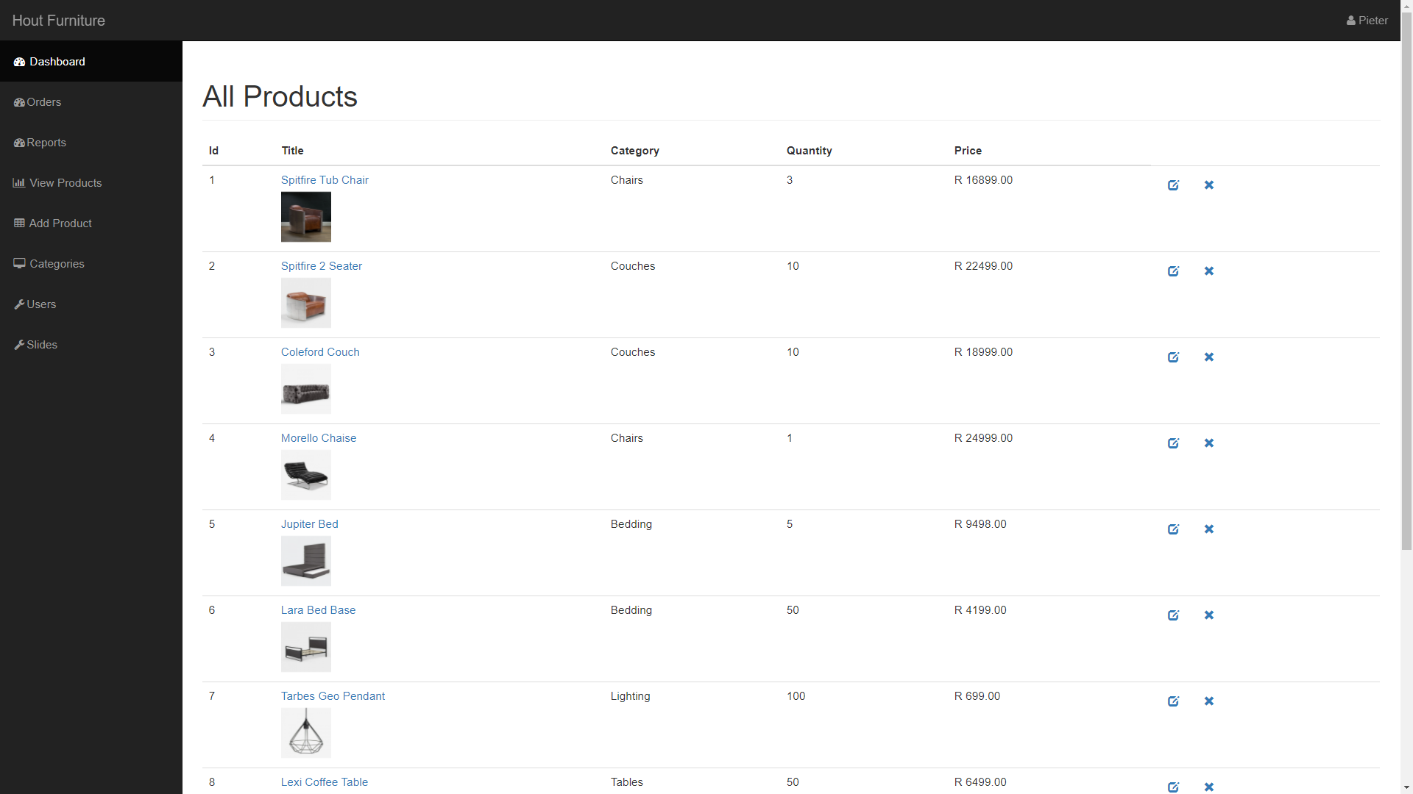

## Edit Products

After clicking the edit icon on the right side of a product the edit product page will be displayed showing all the information about a product currently available in the database which would ensure that it is easy to change.

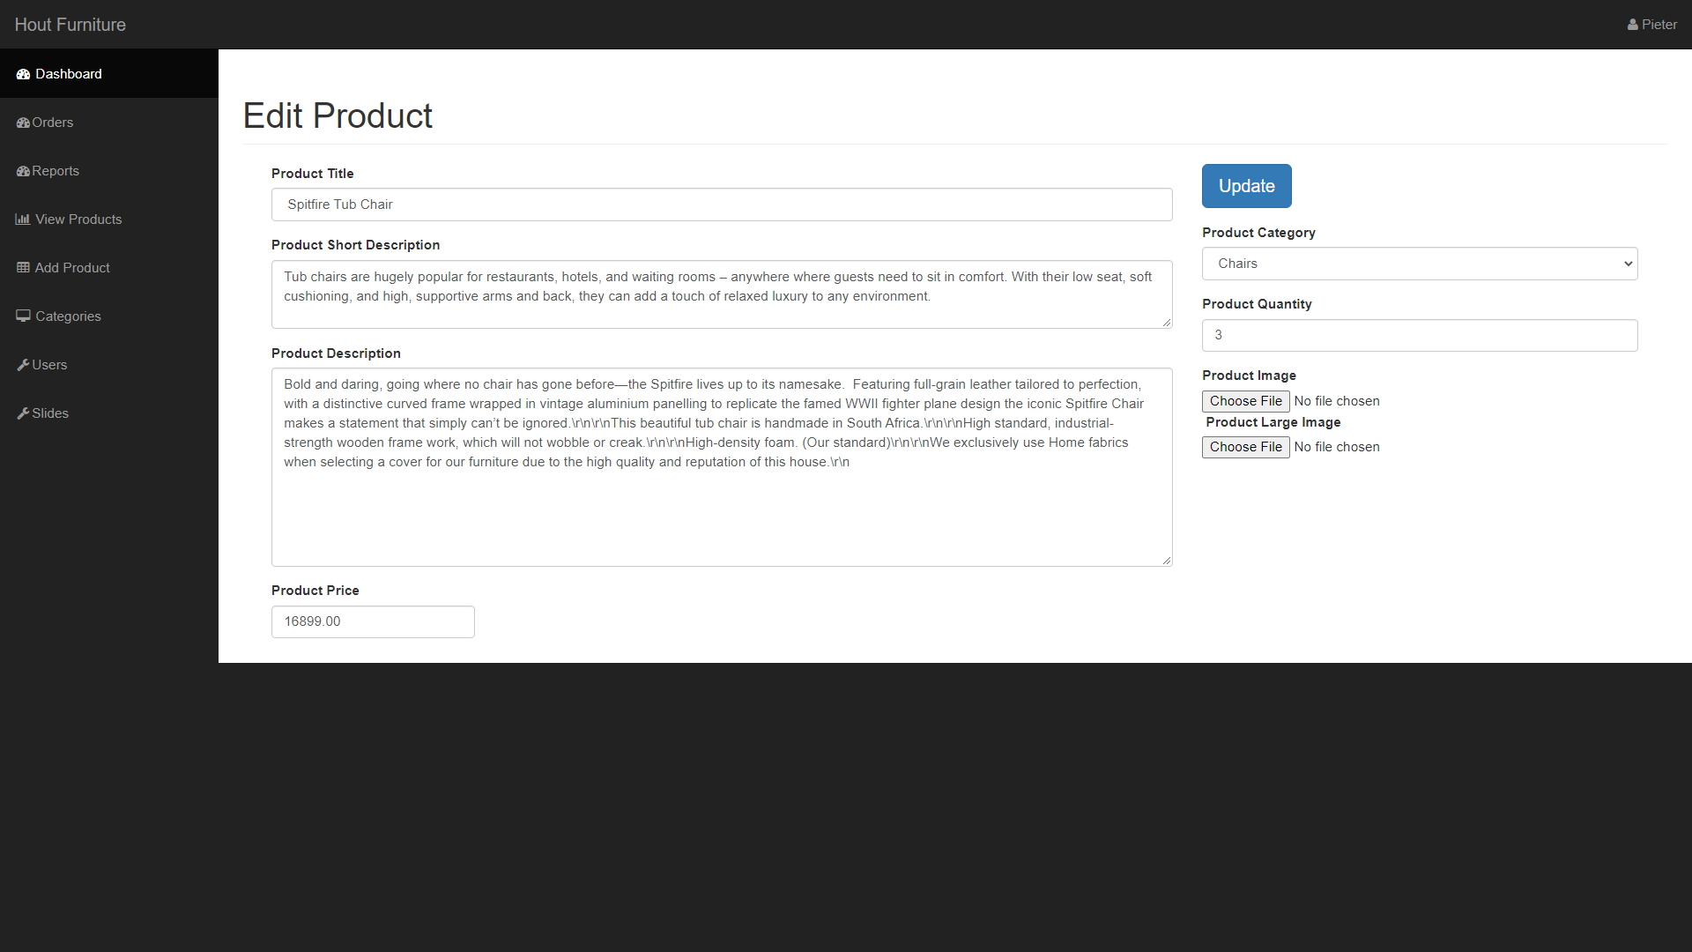

## Add Product

An admin user can also add a product by simply clicking the add product label in the side navigation. Here the admin user will be required to fill in specific information about the product

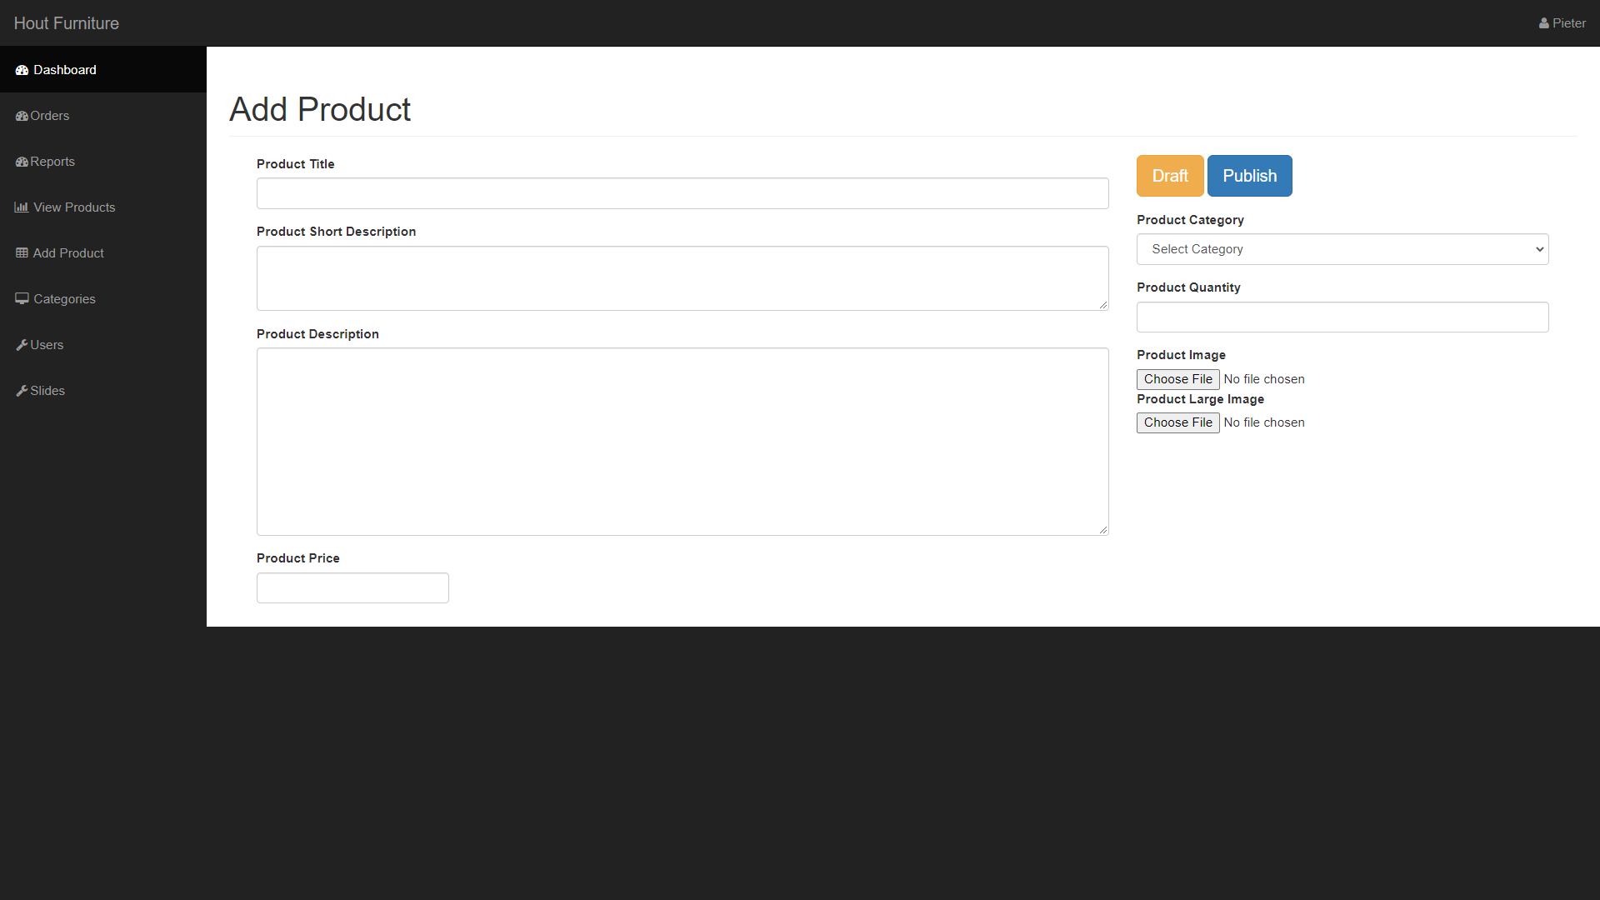

## Product categories

The admin user can also add new categories to the page by simply selecting the Product categories label in the side navigation. This will not only display all of the current categories but it would also allow the admin user to add a new one or remove a current one.

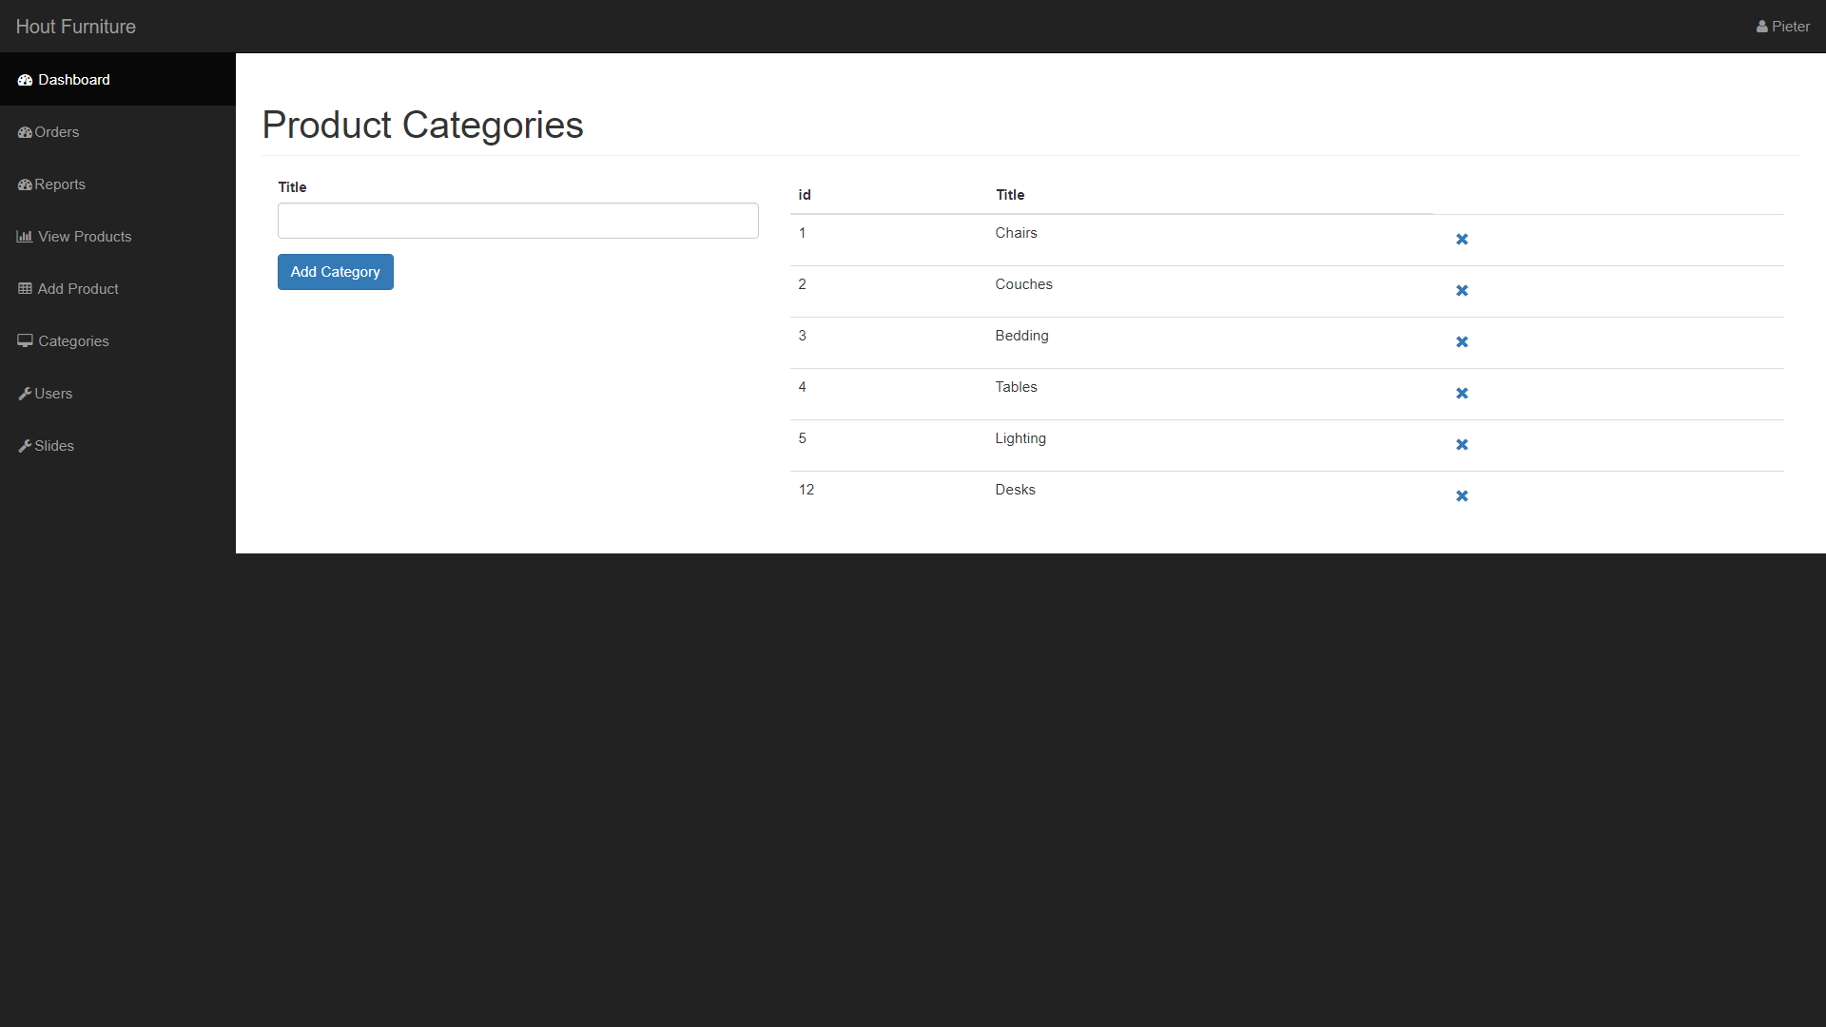

## Slides

Slides are an element that is displayed on the top of the home page, a slide is useful because it allows the admin user to easily send information to the customer regarding things like sales or even new products. An admin user can upload a new slide after selecting the slides label in the side navigation, the admin user will be presented with the slides page, here the admin user can easily upload a new slide.

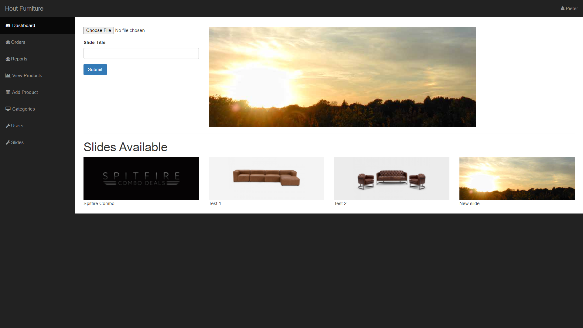

## Logout

Lastly, the admin user can log out by simply clicking their username in the top right corner.